Test Case: tc002_SPX_Dev5_Crear_Requisicion_Spot_Con_FAD_Tipo_Cobro_CC
Step 1 - Enter username and password and click to button Enter : Credentials Entered
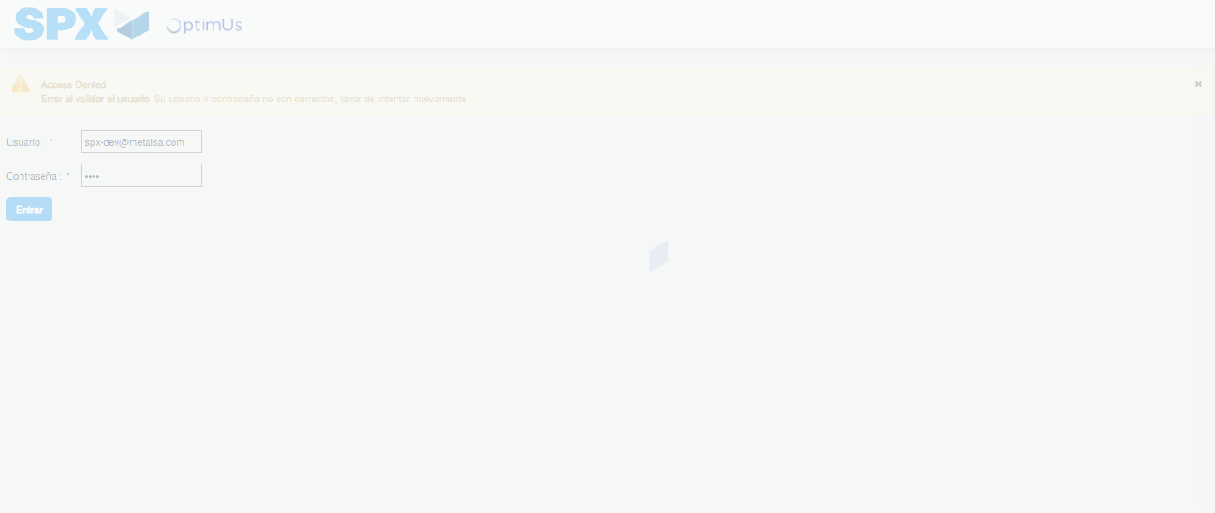Image file-name: QC_Testing-tc002_SPX_Dev5_Crear_Requisicion_Spot_Con_FAD_Tipo_Cobro_CC-1782314611053

Step 2 - Select to UEN and Access to Spot Buy Requisitions : UEN Correctly selected and Correct access
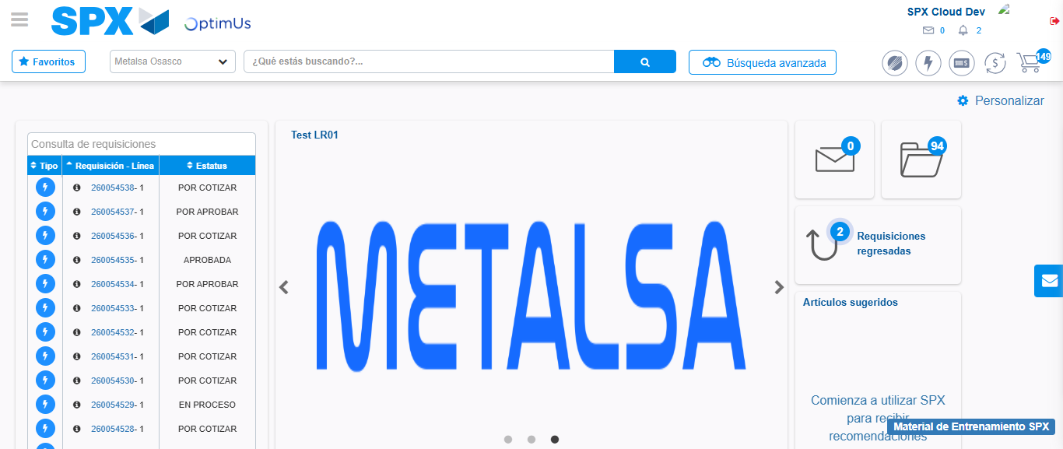Image file-name: QC_Testing-tc002_SPX_Dev5_Crear_Requisicion_Spot_Con_FAD_Tipo_Cobro_CC-1782314684690

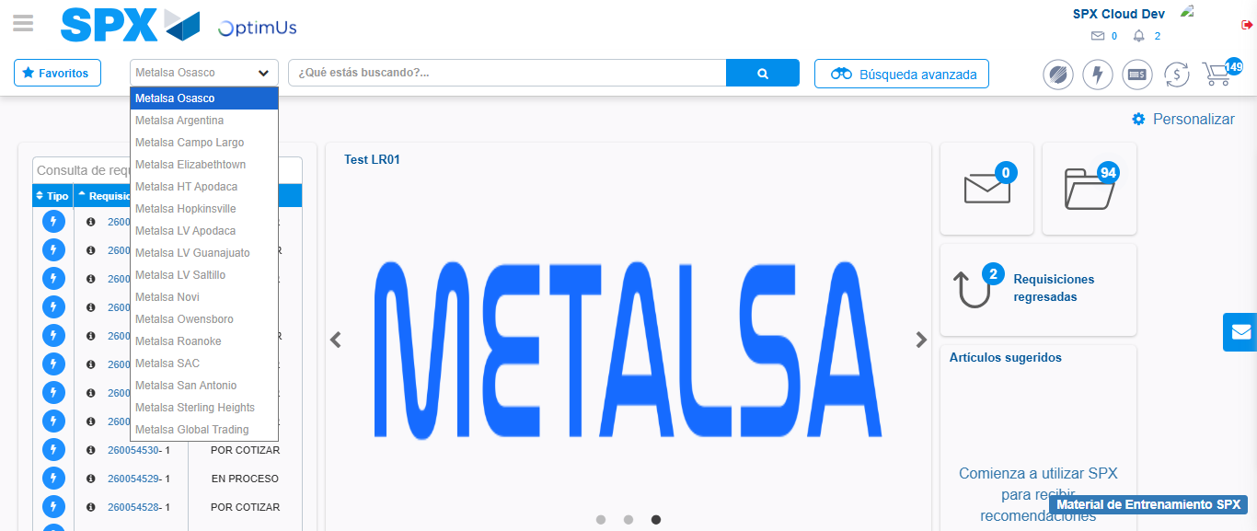Image file-name: QC_Testing-tc002_SPX_Dev5_Crear_Requisicion_Spot_Con_FAD_Tipo_Cobro_CC-1782314687438

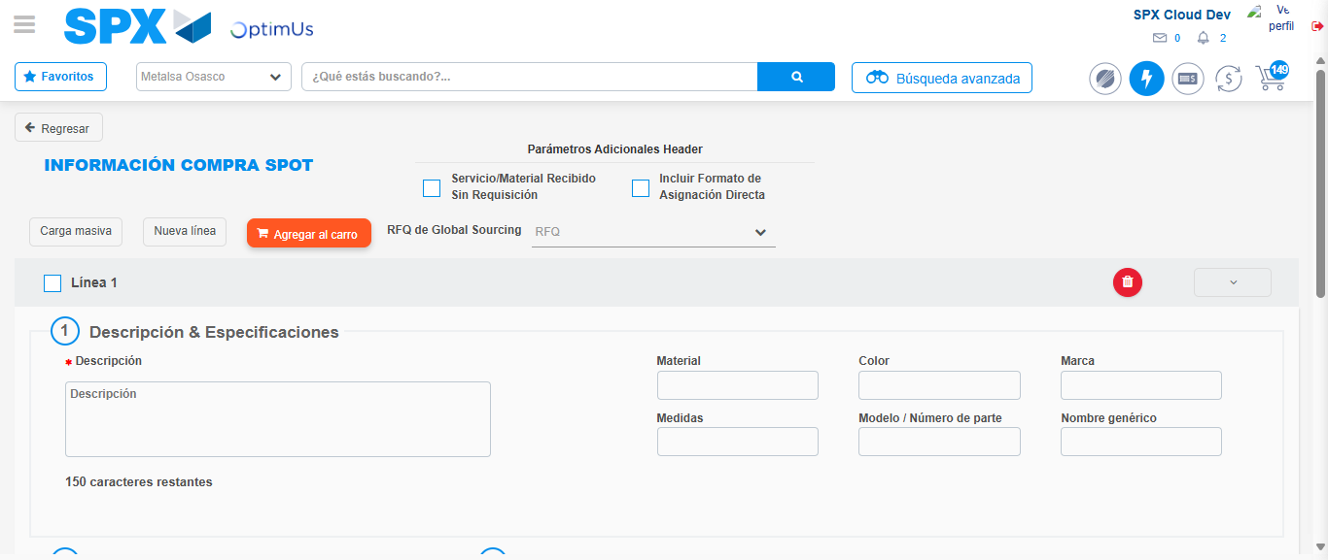Image file-name: QC_Testing-tc002_SPX_Dev5_Crear_Requisicion_Spot_Con_FAD_Tipo_Cobro_CC-1782314695757

Step 3 - Add FAD to Requisition: FAD Successfully Added
Image file-name: QC_Testing-tc002_SPX_Dev5_Crear_Requisicion_Spot_Con_FAD_Tipo_Cobro_CC-1782314696084

Image file-name: QC_Testing-tc002_SPX_Dev5_Crear_Requisicion_Spot_Con_FAD_Tipo_Cobro_CC-1782314696320

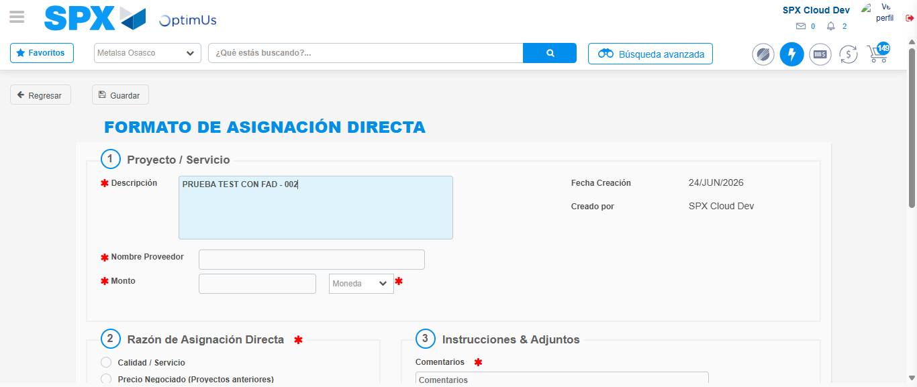Image file-name: QC_Testing-tc002_SPX_Dev5_Crear_Requisicion_Spot_Con_FAD_Tipo_Cobro_CC-1782314699335

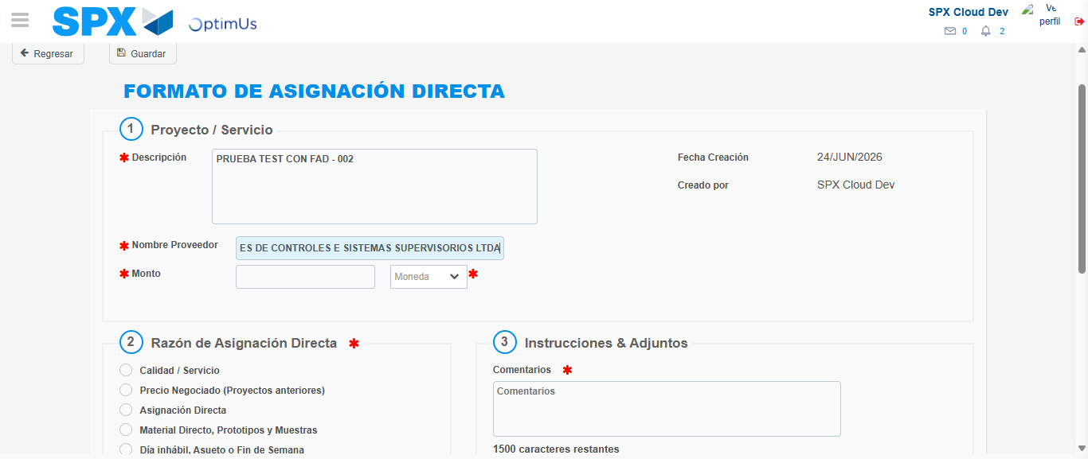Image file-name: QC_Testing-tc002_SPX_Dev5_Crear_Requisicion_Spot_Con_FAD_Tipo_Cobro_CC-1782314710129

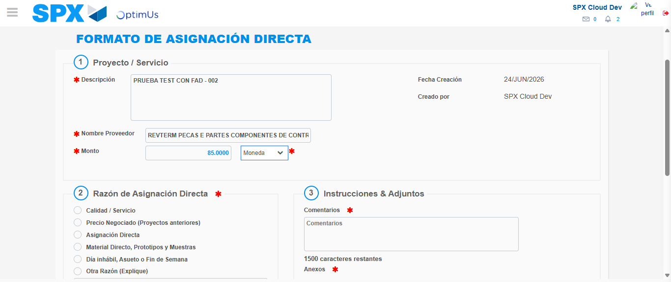Image file-name: QC_Testing-tc002_SPX_Dev5_Crear_Requisicion_Spot_Con_FAD_Tipo_Cobro_CC-1782314710727

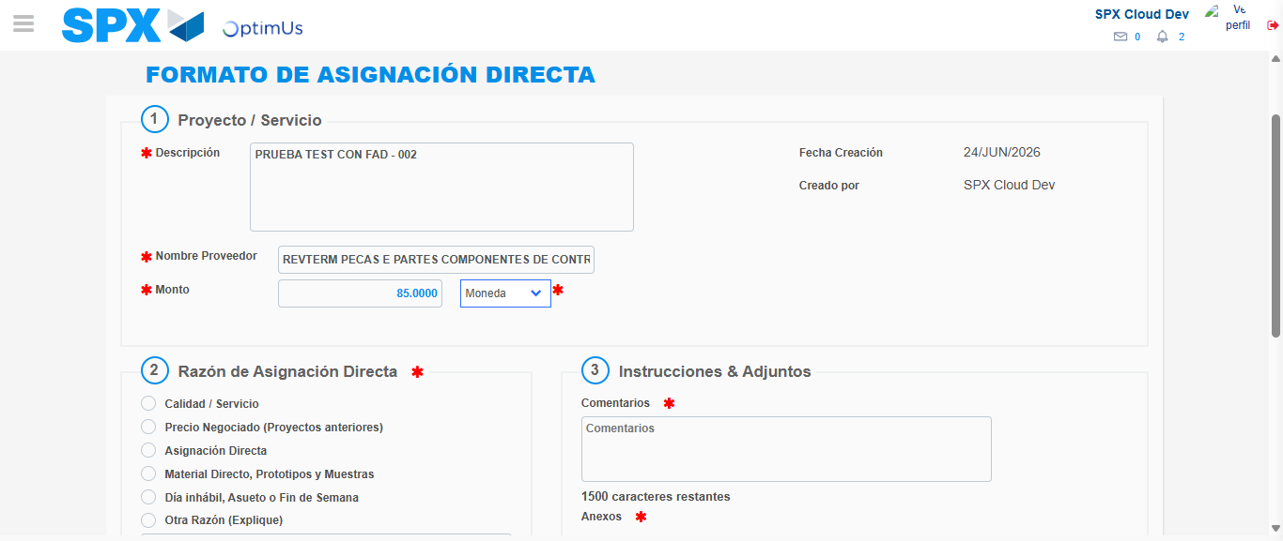Image file-name: QC_Testing-tc002_SPX_Dev5_Crear_Requisicion_Spot_Con_FAD_Tipo_Cobro_CC-1782314711017

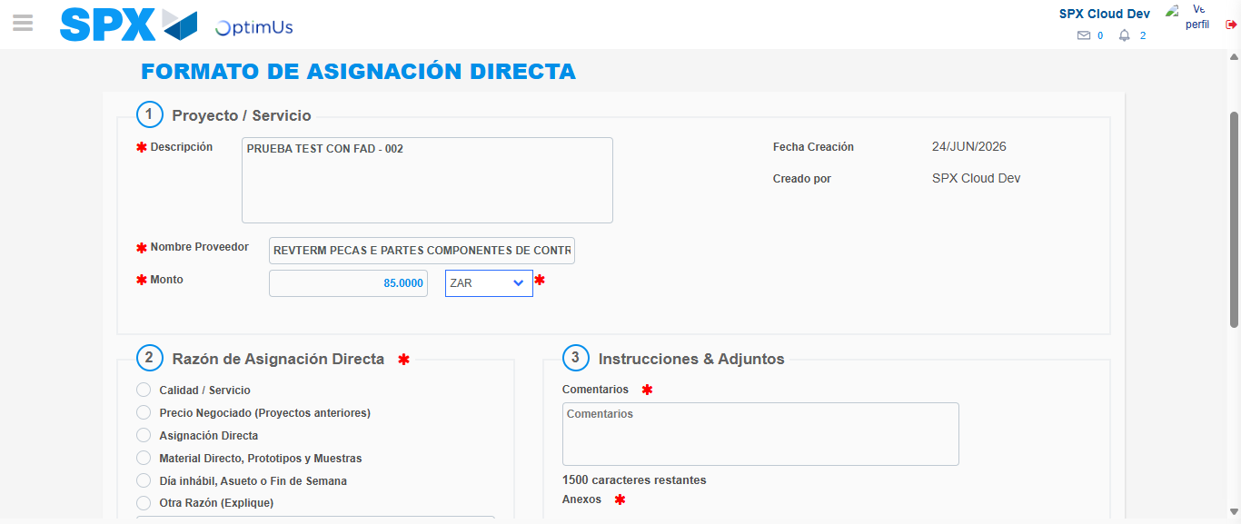Image file-name: QC_Testing-tc002_SPX_Dev5_Crear_Requisicion_Spot_Con_FAD_Tipo_Cobro_CC-1782314711614

Image file-name: QC_Testing-tc002_SPX_Dev5_Crear_Requisicion_Spot_Con_FAD_Tipo_Cobro_CC-1782314711926

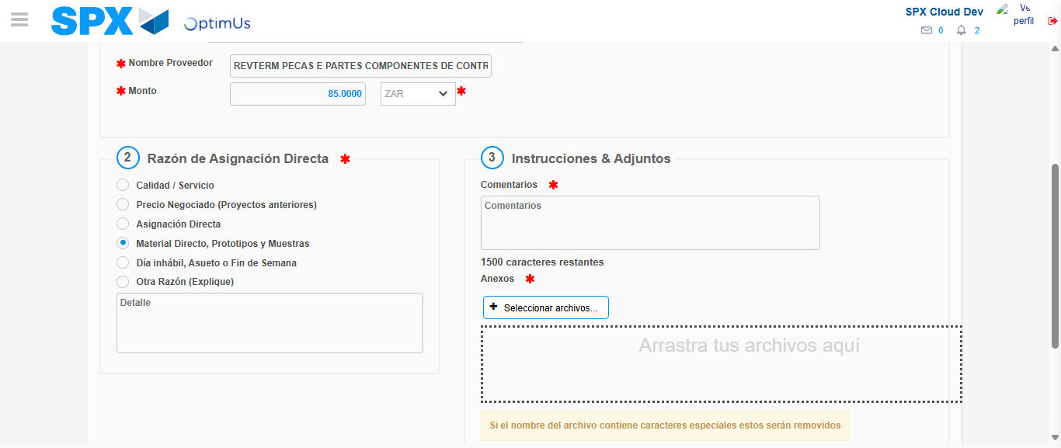Image file-name: QC_Testing-tc002_SPX_Dev5_Crear_Requisicion_Spot_Con_FAD_Tipo_Cobro_CC-1782314712999

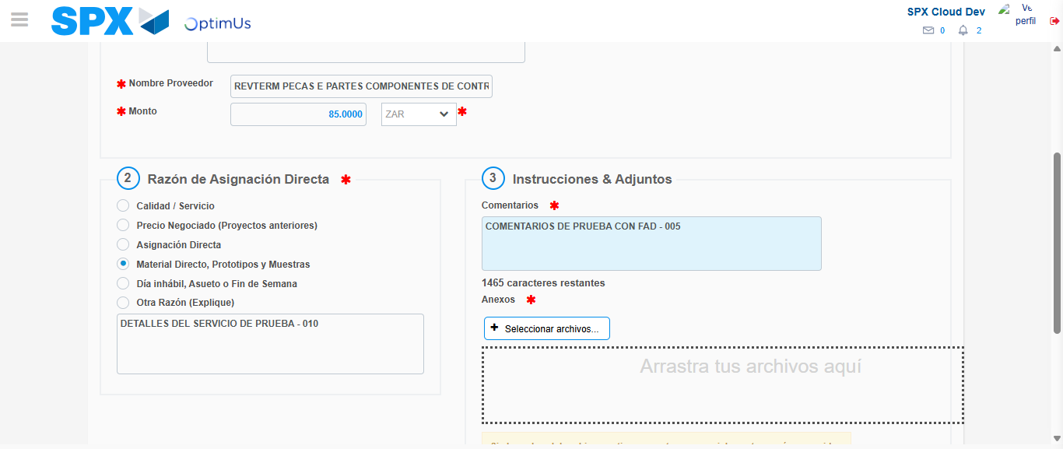Image file-name: QC_Testing-tc002_SPX_Dev5_Crear_Requisicion_Spot_Con_FAD_Tipo_Cobro_CC-1782314724100

Image file-name: QC_Testing-tc002_SPX_Dev5_Crear_Requisicion_Spot_Con_FAD_Tipo_Cobro_CC-1782314725153

Step 4 - Data Capture Spot Buy Requisition: Data captured correctly
Image file-name: QC_Testing-tc002_SPX_Dev5_Crear_Requisicion_Spot_Con_FAD_Tipo_Cobro_CC-1782314696084

Image file-name: QC_Testing-tc002_SPX_Dev5_Crear_Requisicion_Spot_Con_FAD_Tipo_Cobro_CC-1782314696320

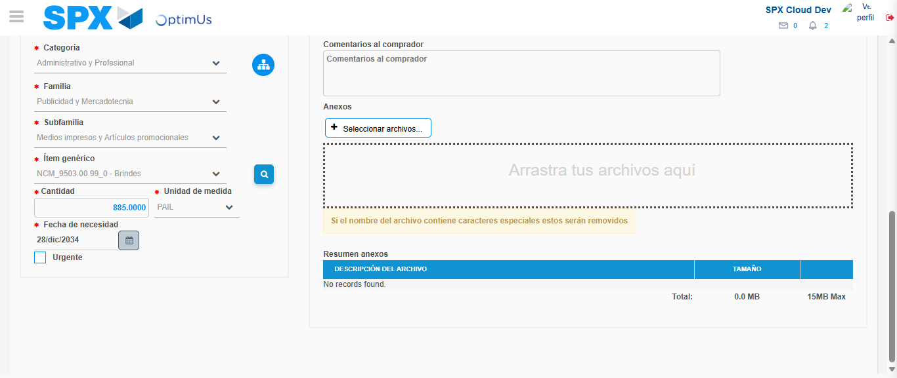Image file-name: QC_Testing-tc002_SPX_Dev5_Crear_Requisicion_Spot_Con_FAD_Tipo_Cobro_CC-1782314740976

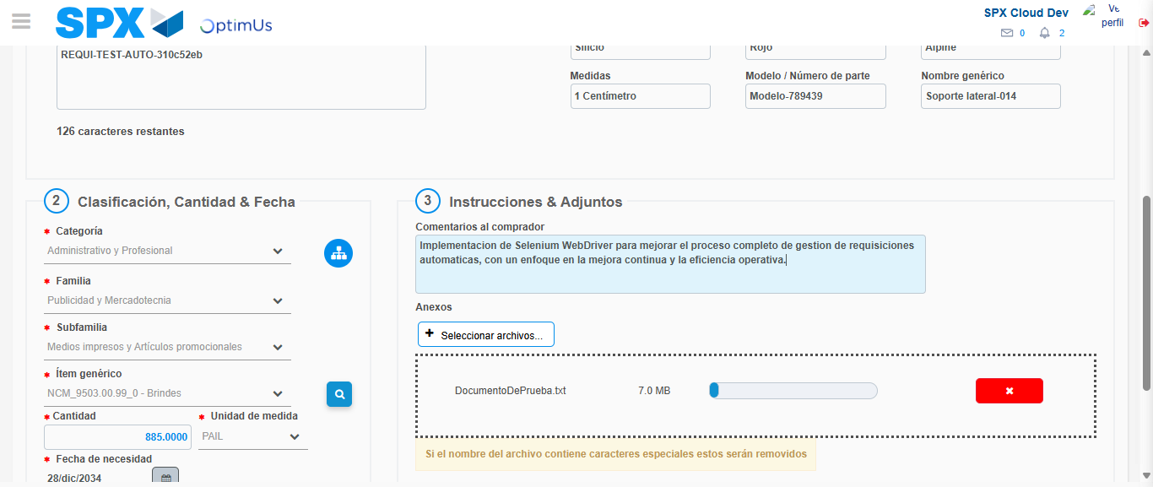Image file-name: QC_Testing-tc002_SPX_Dev5_Crear_Requisicion_Spot_Con_FAD_Tipo_Cobro_CC-1782314741927

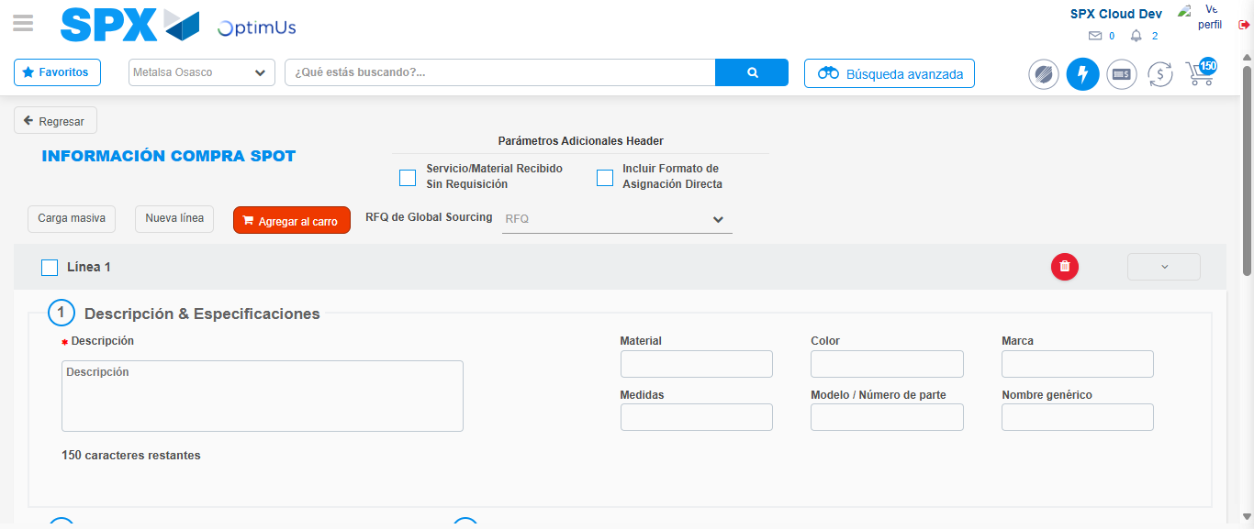Image file-name: QC_Testing-tc002_SPX_Dev5_Crear_Requisicion_Spot_Con_FAD_Tipo_Cobro_CC-1782314753067

Step 8 - Return to Main Page SPX : Return to Main Page SPX
Image file-name: QC_Testing-tc002_SPX_Dev5_Crear_Requisicion_Spot_Con_FAD_Tipo_Cobro_CC-1782314684690

Image file-name: QC_Testing-tc002_SPX_Dev5_Crear_Requisicion_Spot_Con_FAD_Tipo_Cobro_CC-1782314687438

Image file-name: QC_Testing-tc002_SPX_Dev5_Crear_Requisicion_Spot_Con_FAD_Tipo_Cobro_CC-1782314695757

Image file-name: QC_Testing-tc002_SPX_Dev5_Crear_Requisicion_Spot_Con_FAD_Tipo_Cobro_CC-1782314755406

Image file-name: QC_Testing-tc002_SPX_Dev5_Crear_Requisicion_Spot_Con_FAD_Tipo_Cobro_CC-1782314755623

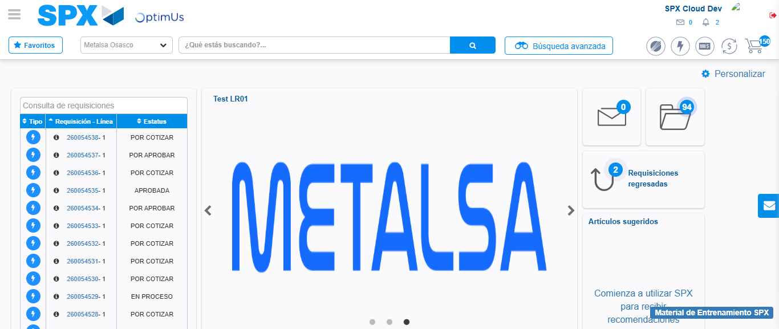Image file-name: QC_Testing-tc002_SPX_Dev5_Crear_Requisicion_Spot_Con_FAD_Tipo_Cobro_CC-1782314777237

Step 9 - Log Out : Log Out SPX
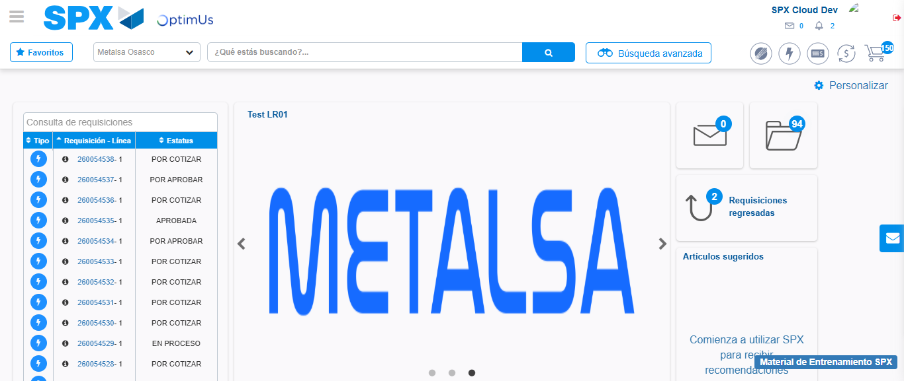Image file-name: QC_Testing-tc002_SPX_Dev5_Crear_Requisicion_Spot_Con_FAD_Tipo_Cobro_CC-1782314777569

